Best tools/tips to ensure browser compatibility in China

The browser usage from Jan.2016 to Oct.2016 in China shows that the top three browser versions are Chrome, IE8.0 and IE9.0, which occupied 39.28%, 17.31% and 5.55%. And for brand ranking, the first three browser brands are chrome (39.28%), IE (29.54%) and QQ (4.67%). It can be seen that summation of other version makes up to 15.79%, which is high as well. (Data from Baidu Tongji) Therefore, it’s very important to ensure website can be compatible on high level browser like Chrome, IE9.0, middle level browser like IE8.0 and low level browser like IE 6.0 (which accounts 2.24%) in China.
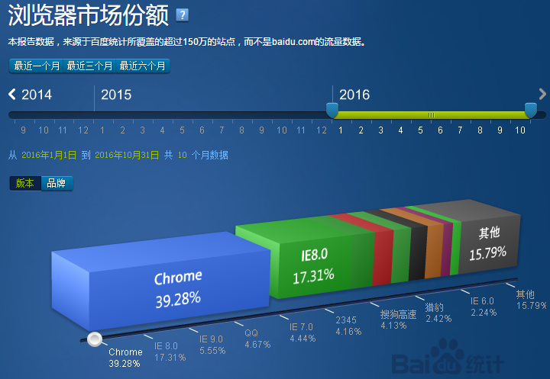
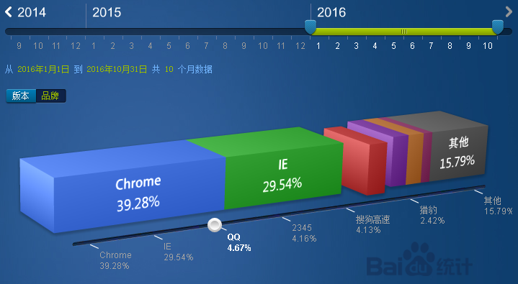
Here are some tips for testing browser compatibility in terms of popular browser versions in China.
- For Chrome, here are three tips for checking website’s compatibility.
- Use “inspection” function to check each element
- Toggle “device toolbar” to check responsive website
- Add extension, for example, “IE tab” to see how the website performance on IE browser
Step: right click mouse, choose “inspection” to see the code of each element. If you would like to check how the website works on different device, click on “toggle device toolbar” on top left, (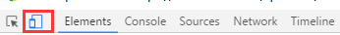)
a device window would show out, you could select different device from device list on the top. (Like the screenshot below)

For IE tab extension, please go to chrome web store, type in “IE tab”, download and install it. After that, you could choose which IE version you want to run on Chrome.
- For IE, nowadays, windows8 or windows7 always have IE9 or IE10 by default, while some html pages ask for opening with IE8 or IE6, especially in China. For this mandatory requirement (especially for online bank page), we can do some setting changes on IE browser.
Step: go to tool bar on browser and choose compatibility view settings, add the website to compatibility view list and kick off “display Intranet site in compatibility view”, and click on “close”.
Once you see the toggle on url bar changed from grey to blue, it means the compatibility view is enabled.
- For QQ browser, go to setting and select sub menu “advance”, then you could choose what kinds of core type you would like to have. There are four types core mode, which are intelligent core mode, superior speed core. IE core and Edge core.
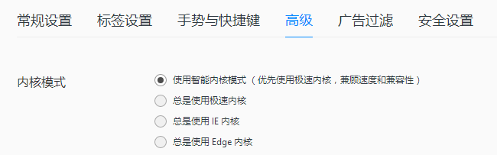

Though these are popular browsers in China, to a digital agency, it’s important to figure out what’s clients’ target user before we develop a website for them, if the target user of client uses more chrome & safari but not IE, the website would need to strengthen the compatibility for safari & chrome and pay less attention to IE.
Therefore, regarding to safari, I would like to recommend “Safari Technology Preview”  , which embraces develop tools like web inspector and responsive design mode to modify, debug, and optimize your websites; and preview the latest layout technologies, visual effects, so you can deliver a good user experience on all Apple devices. Before download this tool, you need to register as an apple developer by icloud account.
When talking about the web browser in China, the one can’t be missed is wechat browser, though it’s for mobile, but this app has over 80 billion users and it’s extremely popular in China. To make sure the compatibility of wechat browser, I would recommend downloading its own web development tool. It offers different versions in terms of devices.
Step: Download the tool from wechat official website and install it. This tool includes wechat browser, debug tool, JS-SDK, Appid and the API we can use, Moile debug and clear cache all these functions. Before you use this developer tool, you have to sign in with your own wechat id to become a wechat app developer. To make sure the website works well on different device, you could use mobile debug to check, please see screenshot below, it has IOS and android devices.
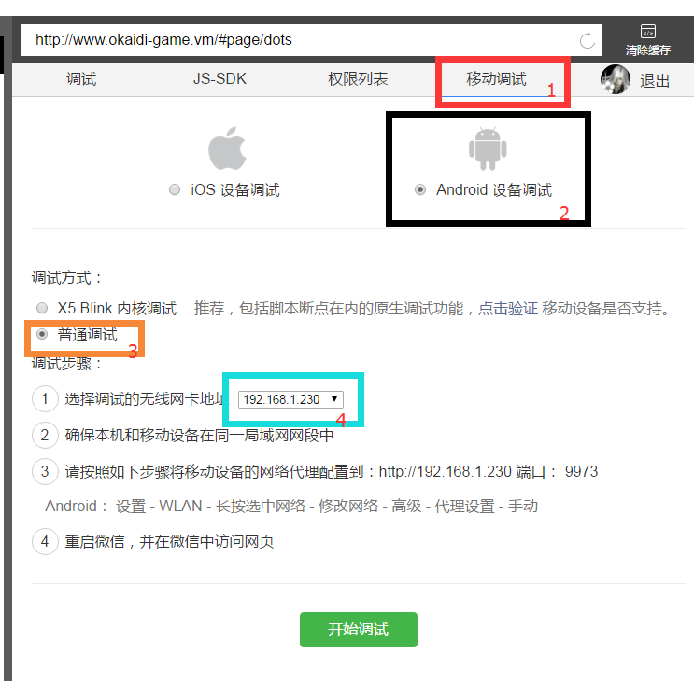

Except using each browser’s own feature to enable compatibility, there are some external tools for ensuring it when doing testing. I would like to recommend tools below:
- BrowserStack

It’s a tool for testing your website for cross browser compatibility on real browsers and stimulated devices. The advantage for this tool is that it’s cloud-based and it enables to do testing on more than 1000 real desktop browsers and constantly updated the latest android and ios devices. In addition, it has quick screenshot feature which is helpful for testing the design and layout. Moreover, the display resolution can be switched from 800 x 600 to 2048 x 1536, this dynamic switch feature is nice for responsive website. The last but not least, browserstack can install native browser on real devices so that the testing results can be more accurate.

- BrowserLing

It’s a live interactive cross-browser testing tool as well. The feature and advantage of it is that it’s not only having screenshots but also interact with browsers live. And it offers bug hunter feature which can quickly pinpoint design issues and bugs on website. Besides, it launches extension so that it can be used just by one click. Moreover, responsive testing can be achieved by changing screen resolution when do testing by browserling. The last but the least is that it will offer video record function soon so that the testing can be more accurate expressed to developers or related persons, which is extremely helpful when doing testing for ensuring browser compatibility. But remember that, if you are going to use it without any payment, you can only do testing within three minutes.

